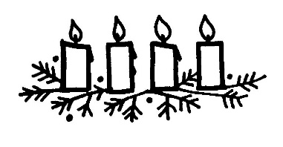
St FRANCIS ADVENT MARKET in the Garden
5 December 2021 9.30 – 11
Do join us on Sunday after church. Mince pies and tea will be served while you explore…
Please remember..
…the market is outdoors (PPE’s in place),
….to wear a mask,
…to bring cash as it is a cash only market.
Stalls include:
Plants
Baked goods
Natural creams, balms and soap
Jewellery
Jams
Christmas decorations
Creative gift ideas
10 % of all sales will be donated to St Francis and then for St Francis there will be…
2 x Beautiful crotched blankets raffled
Christmas cake stir up with Bart…cash donations for ingredients most welcome

