Church Unusual - Live from St Francis: A Liturgy for the Season of Creation 2020 (Adapted from the Iona Abbey Sunday Liturgy (Wild Goose Publications) and the ACSA Season of Creation 2020)

WELCOME

The Lord be with you And also with you
Eternal God, Maker of the skies above, lowly Christ, Lover of the earth and its people, creative Spirit, Giver of gracious gifts You are present among us.
WE GLORIFY GOD
With nature in its power and beauty,
With rain and wind and sunshine,
with the ancient rocks and the budding flower,
we gather in praise of God.
With believers and seekers the whole world wide,
with people in every land,
and speakers of every language,
we gather in praise of God.
With the angels and saints in heaven,
with all who build community here
and with all who worship at this time
we gather in praise of God.
With Jesus who promised his presence
and the Spirit who showers her blessings,
we gather in praise of God.
Here let heaven and earth embrace;
here may God’s people find a home. Amen

PRAYER FOR YOUNG PEOPLE

A TIME OF PENITENCE AND RENEWAL
As bearers of your image, we come to be reshaped; dependent on your mercy, we ask to be made new.

Lord, have mercy Lord, have mercy
Christ, have mercy Christ, have mercy
Lord, have mercy Lord, have mercy

For the right roads we avoided travelling, and the kindly words we refused to share;
for the false gods who received our worship and the true selves we have starved of love
God, by your grace, Forgive us (Pause)
For the hidden hurts we have held too tightly, and the promises which we never kept;
for the careless use of our time and money and the lame excuses we should never have made,
God, by your grace, Forgive us (Pause)
For all we should be and all we can amend,
God, in your love, Renew us.

THE ABSOLUTION

THE COLLECT OF THE DAY

AFFIRMATION OF OUR FAITH
We believe in God above us, Maker and Keeper of all life,
of sun and moon, of water and earth, of male and female.

We believe in God beside us, Jesus Christ, the Word made flesh,
born of a woman, servant of the poor, tortured and nailed to a tree.
A man of compassion, he died forsaken; he descended into the earth to the place of death.
On the third day he rose from the tomb; he ascended into heaven to be everywhere present;
and his kingdom will come on earth.

We believe in God within us, the Holy Spirit of Pentecostal fire,
life-giving breath of the church, spirit of healing and forgiveness,
source of resurrection and eternal life. Amen

THE WORD OF GOD
Listen for God’s word coming to us in Scripture.
Our hearts and minds are open.

READINGS

THE REFLECTION

THE PRAYERS OF THE CHURCH

THE PEACE
The peace of the Lord be with you. Peace be with you.

THE COMMUNION

The Lord be with you And also with you
Lift up your hearts We lift them up to God
Let us give thanks to God our Maker It is right to give God thanks and praise

We thank you that we can come together in the name of Jesus your Son, the first born of all creation. In him all things were created and all things hold together. We thank you that you have sent your Holy Spirit to make of us a community of faith to serve you within your creation. And now we give you thanks because you have given the earth into our care, and call us to praise you for the marvels of your creation. And, so with the wonders of creation and the songs of praise of all your creatures both in heaven and on earth we join in one great act of awe and adoration:
Holy, holy, holy Lord, God of power and might, heaven and earth are full of your glory.
Hosanna in the highest. Blessed is the One who comes in the name of the Lord.
Hosanna in the highest.
God hear us, through Jesus Christ your son, and grant that by the power of the Holy Spirit these gifts of bread and wine may be to us his body and his blood.

Because you, gracious God, have been faithful to us, we will be faithful to Jesus. He promised to be with those who met in his name: this we believe.
He promised to hear the prayers of faithful people: this we believe.
He said that in the communion of bread and wine he would be present to us as we remembered him:
this we celebrate.
So, send now your Spirit among us and upon this bread and wine, that we may realise and see your goodness, be embraced by your love, and be engaged in your service. Amen.

As Jesus did, so we do. We break this bread (the bread is broken)
We share this wine (the cup is raised)
We believe that he who lived, died and rose again for us meets us here.

Therefore we pray as Christ has taught us we are bold to say,
Our Father in heaven, hallowed be your Name, your kingdom come, your will be done on earth as in heaven. Give us today our daily bread. Forgive us our sins as we forgive those who sin against us. Save us from the time of trial and deliver us from evil. For the kingdom, the power, and the glory are yours now and forever. Amen.
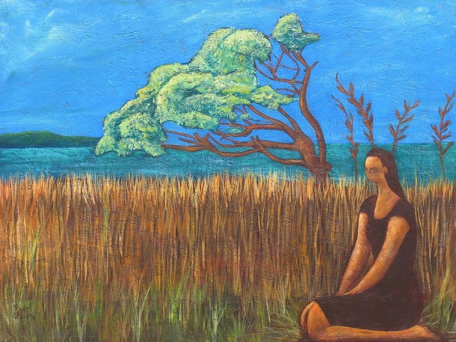
Graciously sustain us, O Christ, so that we who try to follow, may receive nourishment for the journey and be bound in solidarity with all who walk in your way.
Lord Jesus,
The greatest gift is the gift of self
And you emptied yourself that we might be filled.
Fill us now with the gift of your presence
As we commune with you in spirit and truth.
Stretch out your wings to shield and protect us.
Hold us by your strong right hand.
Help us to grow in communion with you
That we may become what we long to receive. Amen

A moment of silence
Loving God, we thank you for nourishing us with these spiritual gifts: may our communion strengthen us in faith, build us up in hope, and make us grow in love; for the sake of Jesus Christ our Lord. Amen

CONCLUSION:
Give thanks for all God’s goodness: God’s love shall last for ever.
Generous and faithful God, may the spiritual nourishment we have received enable us to enrich the lives of others. Whether the future be dark or bright, the road be smooth or rough, whether our cares be light or heavy, our song be strong or weak, keep our hearts warm and our hands open, our lives ever embracing and ever embraced by your love. Amen.
God bless Africa, guard our children, guide our leaders, and give us peace. For Jesus Christ’s sake, Amen.
THE BLESSING
May God who established the dance of creation, who marvelled at the lilies of the field,
who transforms chaos to order, lead us to transform our lives and our community,
to reflect God’s glory in creation, and the blessing of God almighty, Creator, Redeemer and Sustainer
be with us all, One God, Now and Forever, Amen

SOME NOTICES

THE SENDING- As you go, care for all creation as you love and serve the Lord In the name of Christ. Amen

